“A Q&A with JD Deardourff, the Artist behind Uncanny Fantastic”
Published online through On Tap Magazine
By Michael Loria
January 23, 2018
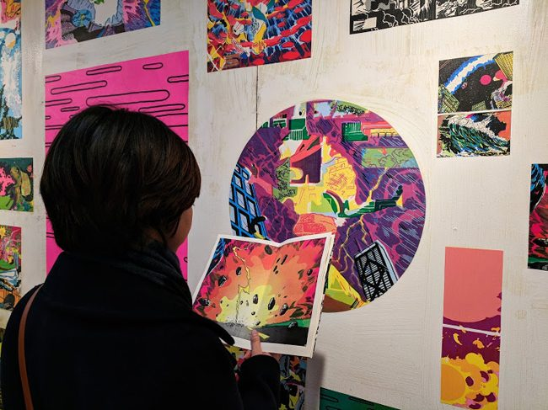

“SPACE4, a shipping container converted into an art gallery, is now home to JD Deardourff’s Uncanny Fantastic, a body of work inspired by Deardourff’s own abstract collages of comic book imagery. Deardourff’s comic-style pieces are now firmly supplanted at the Union Market, as the mobile art space continues its mission to appear at unconventional venues across DC.
The exhibit accompanies a book release of Uncanny Fantastic. At On Tap, I was able to do a brief Q&A with JD over the phone, in which I got to ask him about his inspirations and furry assistants.
On Tap: To start, you want tell us a little about yourself. I had trouble finding much online.
JD Deardourff: Absolutely. So, the reason there’s not that much about me online right now is because my website is down, which is a bummer. But I’m from Virginia, and then I went to Davidson College in North Carolina, and then I transfered from there to the School of the Art Institute of Chicago, and I graduated in 2012 and moved back to DC, and I’ve been an artist slash working odd jobs here ever since.
[……]
JD: I do, there’s one in a restaurant called Honeygrow in Chinatown. There’s one in NOMA, that I did for Pow! Wow! DC which is like a mural festival, and that’s on the corner of First and Pierce in NOMA. Those are the only two that are open to the public. There are a couple others in apartment buildings. My next project is one I’m doing on the bottom of a pool for a building called Central in Silver Spring. And then I’m working on one for this place on 14th. And there’s another one I’m actually doing with CulturalDC which is next to the Hyatt Hotel on the corner of 23rd and Virginia. Those are the three upcoming ones.
OT: What else do you have coming up?
JD: The community workshops which will be open to the public. They’re going to be hands on screen printing demonstrations, and right now I think the idea is that people will print the last layer of a poster they can take with them. Another part of the exhibit is that the artwork is wheatpasted onto the walls, which is like a homemade glue. So, I think I’m also going to include a wheatpaste demonstration as well. Yeah screen printing and wheatpasting.
OT: Is the artwork all taken from the book?
JD: Some of it. There’s a crossover for sure. I would say the exhibit is all the work I’ve done for the past four years and the book is like selections of that work.
JD’s Uncanny Fantastic exhibit will be on display through February 23. Look for him to be selling copies of the Uncanny Fantastic book there, or look for him around the city, painting a mural with his Bernedoodle Bruce. The gallery is open Wednesday through Friday, 12 p.m. – 8 p.m. and Saturday and Sunday, 10 a.m. – 8 p.m. There is no admission price

For more on JD, follow his Instagram here. The exhibit is put on by CulturalDC. For more info on the exhibit visit their website www.culturaldc.org.
Union Market DC: 1309 5th St. NE, DC; www.unionmarketdc.com

https://ontaponline.com/2018/01/23/q-and-a-with-jd-deardourff/

